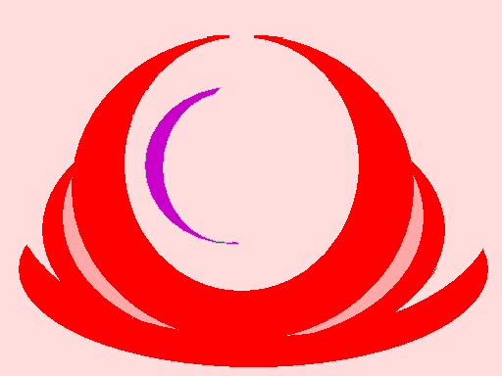
Medical Waiver and Release of Liability Form
1, The Participant assumes all of the risks of participating in the Seraphim Blueprint Covid Recovery Course (hereinafter “Course”) occurring on April 16th and 23rd, 2023. And risks that may arise from negligence or carelessness upon the part of Ruth Rendely, the facilitator of this course.

I certify that the participant is mentally and physically prepared for participating in this course.

In consideration of my registration and permitting me to attend this course, please initial:

A) ___I WAIVE, RELEASE AND DISCHARGE the following entities, or persons: Seraphim Blueprint Corporation, and Ruth Rendely from any and all liability associated from attending this Course.

B) ____INDEMNIFY, HOLD HARMLESS AND PROMISE NOT TO SUE Seraphim Blueprint and Ruth Rendely for any and all liabilities and claims made as a result of participating in this Course whether caused by negligence, release or otherwise.

I acknowledge that Seraphim Blueprint and Ruth Rendely are not responsible for the errors, omissions, acts or failures to act upon the part of this activity or attendance in this Course.

I CERTIFY THAT I HAVE READ THIS DOCUMENT AND FULLY UNDERSTAND ITS CONTENT. I AM AWARE THAT THIS IS A RELEASE OF LIABILITY AND A CONTRACT AND I SIGN IT OF MY OWN FREE WILL.

______________________________________________________________________ Participant's Signature Name Printed Date Age

__________________________________________
Parent/Guardian Signature Date
(If participant is under 18
years old)

